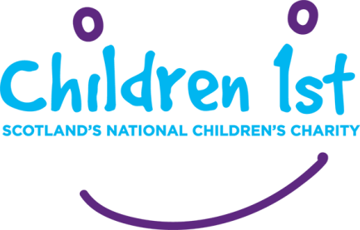 **A Bairnshoose for Scotland**

**Request for Follow Up Support**

|  |  |
| --- | --- |
| Date of request: |  |

**Family details**

|  |  |  |  |
| --- | --- | --- | --- |
| Child’s name: | | DOB: | Gender: |
| Child’s address: | | | |
| Parent/Carer’s name: | Address: | | |
| Phone number: | Email: | | |

|  |
| --- |
| The children/young person/family would like to be contacted by  Phone  Text  Email |
| Please let us know if there is a day that the family would most like the Bairnshoose Team to get in touch:  Monday/Tuesday/Wednesday/Thursday/Friday  And if it is better to call in the morning/afternoon/early evening |

**Key professionals:**

|  |  |  |
| --- | --- | --- |
| Name: | Relationship to child: | Contact Details: |
|  |  |  |
|  |  |  |
|  |  |  |

**Please give a summary of the background to the young person/family situation so they do not have to repeat their story, if they do not want to:**

|  |
| --- |
|  |

|  |  |
| --- | --- |
| Contact for the West of Scotland  Rachel Dhillon  Phone: 07960779982  [Email: bairnshoose@children1st.org.uk](mailto:Email:bairnshoose@children1st.org.uk) | Contact for the East of Scotland  Claire O’Donnell  Phone: 07920531525  Email: [bairnshoose@children1st.org.uk](mailto:bairnshoose@children1st.org.uk) |